CS229 Lecture notes

原作者：[Andrew Ng](http://cs229.stanford.edu/)（[吴恩达](http://open.163.com/movie/2008/1/M/C/M6SGF6VB4_M6SGHFBMC.html)）

翻译：[CycleUser](https://zhuanlan.zhihu.com/python-kivy)

Part V

支持向量机（Support Vector Machines）

本章的讲义主要讲述的是 支持向量机( Support Vector Machine ，缩写为 SVM) 学习算法。SVM 算得上是现有的最好的现成的（“off-the-shelf”）监督学习算法之一，很多人实际上认为这里没有“之一”这两个字的必要，认为 SVM 就是最好的现成的监督学习算法。讲这个 SVM 的来龙去脉之前，我们需要先讲一些关于边界的内容，以及对数据进行分割成大的区块（gap）的思路。接下来，我们要讲一下最佳边界分割器（optimal margin classifier,），其中还会引入一些关于拉格朗日对偶（Lagrange duality）的内容。然后我们还会接触到核（Kernels），这提供了一种在非常高的维度（例如无穷维度）中进行 SVM 学习的高效率方法，最终本章结尾部分会讲 SMO 算法，也就是 SVM 算法的一个有效实例。

1 边界（Margins）:直觉（Intuition）

咱们这回讲 SVM 学习算法，从边界（margins）开始说起。这一节我们会给出关于边界的一些直观展示（intuitions），以及过对于我们做出的预测的信心（confidence）；在本章的第三节中，会对这些概念进行更正式化的表述。

考虑逻辑回归，其中的概率分布p(y = 1|x; θ) 是基于 hθ(x) = g(θTx) 而建立的模型。当且仅当 hθ(x) ≥ 0.5 ，也就是 θTx ≥ 0 的时候，我们才会预测出“1”。假如有一个正向（Positive）的训练样本（positive training example）（y = 1）。那么θTx 越大，hθ (x) = p(y = 1|x; w, b) 也就越大，我们对预测 Label 为 1 的“信心（confidence）”也就越强。所以如果 y = 1 且 θT x ≫ 0（远大于 0），那么我们就对这时候进行的预测非常有信心，当然这只是一种很不正式的粗略认识。与之类似，在逻辑回归中，如果有 y = 0 且 θT x ≪ 0（远小于 0），我们也对这时候给出的预测很有信心。所以还是以一种非常不正式的方式来说，对于一个给定的训练集，如果我们能找到一个 θ，满足当 y(i) = 1 的时候总有 θT x(i) ≫ 0，而 y(i) = 0 的时候则 θT x(i) ≪ 0，我们就说这个对训练数据的拟合很好，因为这就能对所有训练样本给出可靠（甚至正确）的分类。似乎这样就是咱们要实现的目标了，稍后我们就要使用**函数边界记号**（**notion of functional margins**）来用正规的语言来表达该思路。

还有另外一种的直观表示，例如下面这个图当中，画叉的点表示的是正向训练样本，而小圆圈的点表示的是负向训练样本，图中还画出了**分类边界**（**decision boundary**），这条线也就是通过等式 θT x = 0 来确定的，也叫做**分类超平面**（**separating hyperplane**）。图中还标出了三个点 A，B 和 C。

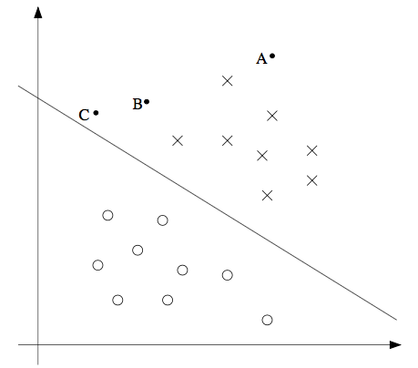

可以发现 A 点距离分界线很远。如果我们对 A 点的 y 值进行预测，估计我们会很有信心地认为在那个位置的 y = 1。与之相反的是 C，这个点距离边界线很近，而且虽然这个 C 点也在预测值 y = 1 的一侧，但看上去距离边界线的距离实在是很近的，所以也很可能会让我们对这个点的预测为 y = 0。因此，我们对 A 点的预测要比对 C 点的预测更有把握得多。B 点正好在上面两种极端情况之间，更广泛地说，如果一个点距离**分类超平面**（**separating hyperplane**）比较远，我们就可以对给出的预测很有信心。那么给定一个训练集，如果我们能够找到一个分类边界，利用这个边界我们可以对所有的训练样本给出正确并且有信心（也就是数据点距离分类边界要都很远）的预测，那这就是我们想要达到的状态了。当然上面这种说法还是很不正规，后面我们会使用**几何边界记号**（**notion of geometric margins**）来更正规地来表达。

2 记号（Notation）

在讨论 SVMs 的时候，出于简化的目的，我们先要引入一个新的记号，用来表示分类。假设我们要针对一个二值化分类的问题建立一个线性分类器，其中用来分类的标签（label）为 y，分类特征（feature）为 x。从此以后我们就用 y ∈ {−1, 1} (而不是之前的 {0, 1}) 来表示这个分类标签了。另外，以后咱们也不再使用向量 θ 来表示咱们这个线性分类器的参数了，而是使用参数 w 和 b，把分类器写成下面这样：

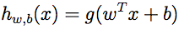

当 z ≥ 0，则 g(z) = 1；而反之若 z ＜ 0，则g(z) = -1。这里的这个 “w, b” 记号就可以让我们能把截距项（intercept term）b 与其他的参数区别开。（此外我们也不用再像早些时候那样要去设定 x0 = 1 这样的一个额外的输入特征向量了。）所以，这里的这个参数 b 扮演的角色就相当于之前的参数 θ0 ，而参数 w 则相当于 [θ1 . . . θn]T。

还要注意的是，从我们上面对函数 g 的定义，可以发现我们的分类器给出的预测是 1 或者 -1 （参考 感知器算法 perceptron algorithm），这样也就不需要先通过中间步骤（intermediate step）来估计 y 为 1 的概率（这就是逻辑回归中的步骤）。

3 函数边界和几何边界（Functional and geometric margins）

咱们来用正规语言来将函数边界和几何边界的记号的概念进行正规化。给定一个训练集 (x(i), y(i))，我们用下面的方法来定义对应该训练集的函数边界 (w, b)：

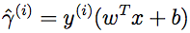

要注意，如果 y(i) = 1，那么为了让函数边界很大（也就是说，我们的预测很可信并且很正确），我们就需要 wT x + b 是一个很大的正数。与此相对，如果 y(i) = −1，那么为了让函数边界很大，我们就需要wT x + b 是一个很大（绝对值）的负数。而且，只要满足 y(i)(wT x + b) > 0，那我们针对这个样本的预测就是正确的。（自己检验证明吧。）因此，一个大的函数边界就表示了一个可信且正确的预测。

对于一个线性分类器，选择上面给定的函数 g （取值范围为{−1, 1}），函数边界的一个性质却使得这个分类器并不具有对置信度的良好量度。例如上面给定的这个函数 g，我们会发现，如果用 2w 替换掉 w，然后用 2b 替换 b，那么由于有 g(wTx + b) = g(2wTx + 2b)，所以这样改变也并不会影响 hw,b(x)。也就是说，函数 g 以及 hw,b(x) 只取决于 wT x + b 的正负符号（sign），而不受其大小（magnitude）的影响。然而，把(w, b) 翻倍成 (2w,2b) 还会导致函数距离也被放大了 2 倍。因此，这样看来就是只要随意去调整 w 和 b 的范围，我们就可以人为调整函数边界到足够大了，而不用去改变任何有实际意义的变量。直观地看，这就导致我们有必要引入某种归一化条件，例如使 ||w||2 = 1；也就是说，我们可以将 (w, b) 替换成 (w/||w||2,b/||w||2)，然后考虑对应 (w/||w||2,b/||w||2) 的函数边界。我们稍后再详细讨论这部分内容。

给定一个训练集 S = {(x(i),y(i)); i = 1, ..., m}，我们将对应 S 的函数边界 (w, b) 定义为每个训练样本的函数边界的最小值。记作 γˆ，可以写成：

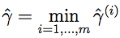

接下来，咱们要讲的是几何边界（geometric margins）。例如下图所示：

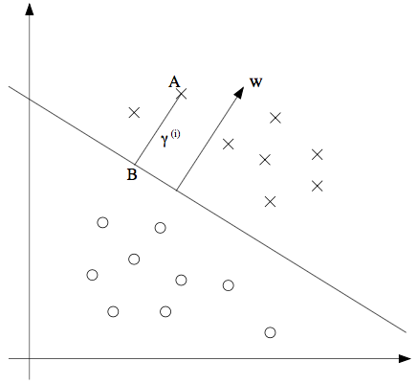

图中给出了对应 (w, b) 的分类边界，其倾斜方向（即法线方向）为向量 w 的方向。这里的向量 w 是与**分类超平面**垂直的（orthogonal，即夹角为 90°）。（你需要说服自己现实情况一定是这样的。）假设有图中所示的一个点 A，此点表示的是针对某训练样本的输入特征为 x(i) ，对应的标签（label）为 y(i) = 1。然后这个点到分类边界的距离 γ(i), 就通过 AB 之间的线段能够获得。

怎么找到的 γ(i) 值呢？这样，w/||w|| 是一个单位长度的向量，指向与 w 相同的方向。因为这里 A 点表示的是 x(i)，所以就能找到一个点 B，其位置为 x(i) − γ(i) · w/||w||。这个 B 点正好位于分类边界线上面，而这条线上的所有 x 都满足等式 wT x + b = 0 ，所以有：

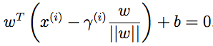

通过上面的方程解出来的 γ(i) 为：

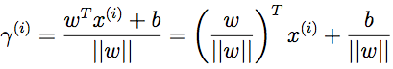

这个解是针对图中 A 处于训练样本中正向部分这种情况，这时候位于“正向（positive）”一侧就是很理想的情况。如果更泛化一下，就可以定义对应训练样本 (x(i), y(i)) 的几何边界 (w, b) 为：

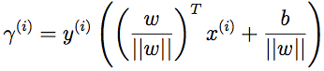

这里要注意，如果 ||w|| = 1，那么函数边界（functional margin）就等于几何边界（geometric margin）——我们可以用这种方法来将两个边界记号联系起来。此外，几何边界是不受参数缩放的影响的；也就是说，如果我们把 w 改为 2w，b 改为 2b，那么几何边界并不会改变。稍后这个性质就会派上用场了。特别要注意的是，由于这个与参数缩放的无关性，当试图对某个数据集的 w 和 b 进行拟合的时候，我们就可以倒入一个任意设置的缩放参数来约束 w，而不会改变什么重要项；例如，我们可以设置 ||w|| = 1，或者 |w1| = 5，或者 |w1 +b|+|w2| = 2，等等都可以，这些都只需要对 w 和 b 进行缩放就可以满足了。

Finally, given a training set S = {(x(i), y(i)); i = 1, . . ., m}, we also define the geometric margin of (w, b) with respect to S to be the smallest of the geometric margins on the individual training examples:

最后，给定一个训练集 S = {(x(i), y(i)); i = 1, ..., m}，我们也可以我们将对应 S 的几何边界 (w, b) 定义为每个训练样本的几何边界的最小值：

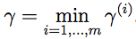

4 最优边界分类器（optimal margin classifier）

给定一个训练集，根据咱们前文的讨论，似乎很自然地第一要务就是要尝试着找出一个分类边界，使（几何）边界能够最大，因为这会反映出对训练集进行的一系列的置信度很高的分类预测，也是对训练数据的一个良好“拟合（fit）”。这样生成的一个分类器，能够把正向和负向的训练样本分隔开，中间有一个“空白区（gap）”，也就是几何边界。

到目前为止，我们都是假定给定的训练集是线性可分（linearly separable）的；也就是说，能够在正向和负向的样本之间用某种分类超平面来进行划分。那要怎样找到能够得到最大几何边界的那一组呢？我们可以提出下面的这样一个优化问题（optimization problem）：

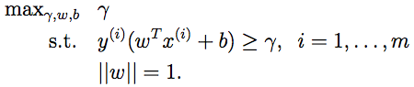

也就是说，我们要让 γ 取最大值，使得每一个训练样本的函数边界都至少为 γ（having functional margin at least γ）。另外 ||w|| = 1 这个约束条件还能保证函数边界与几何边界相等，所以我们就还能够保证所有的几何边界都至少为 γ。因此，对上面这个优化问题进行求解，就能得出对应训练集的最大可能几何边界（largest possible geometric margin）的 (w, b)。

如果解出来上面的优化问题，那就全都搞定了。但 “||w|| = 1” 这个约束条件很讨厌，是非凸的(non-convex)，而且这个优化问题也明显不是那种我们随便扔给某些标准优化软件（standard optimization software）就能解决的。所以我们要把这个问题进行改善，让它更好解。例如：

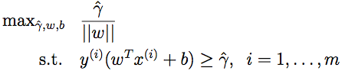

这时候，我们要让 γˆ/||w|| 的取值最大，使得函数边界都至少为 γˆ。由于几何边界和函数边界可以通过 γ = γˆ/||w| 来联系起来，所以这样就能得到我们想要的结果了。而且，这样还能摆脱掉 ||w|| = 1 这个讨厌的约束条件。然而，悲剧的是我们以现在就有了一个很讨厌的（还是非凸的）目标函数 γˆ/||w||；而且，我们还是没有什么现成的软件（off-the-shelf software）能够解出来这样的一个优化问题。

那接着看吧。还记得咱们之前讲过的可以对 w 和 b 设置任意的一个缩放约束参数，而不会改变任何实质性内容。咱们现在就要用到这个重要性质了。下面咱们就来引入一个缩放约束参数，这样针对训练集的函数边界 w, b 的这个参数就可以设置为 1（scaling constraint that the functional margin of w, b with respect to the training set must be 1）：



对 w 和 b 使用某些常数来进行翻倍，结果就是函数边界也会以相同的常数进行加倍，这就确实是一个缩放约束了，而且只要对 w 和 b 进行缩放就可以满足。把这个性质用到咱们上面的优化问题中去，同时要注意到当 γˆ/||w|| = 1/||w|| 取得最大值的时候，||w||2 取得最小值，所以就得到了下面的这个优化问题：

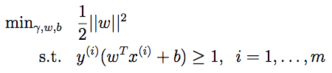

通过上面这样的转换，这个问题就变得容易解决了。上面的问题有一个凸二次对象（a convex quadratic objective），且仅受线性约束（only linear constraints）。对这个问题进行求解，我们就能得到最优边界分类器（optimal margin classifier）。这个优化问题的求解可以使用商业二次规划（commercial quadratic programming ，缩写QP）代码。1

1可能你更熟悉的是线性规划（linear programming），这种方法适用的优化问题是有线性对象（linear objectives）和线性约束（linear constraints）。QP 软件的适用范围也很广泛，其中就包括这种凸二次对象（convex quadratic objectives）和线性约束的情况。

这样，差不多就可以说问题已经得到了解决，接下来咱们就要岔开话题，聊一聊拉格朗日对偶性（Lagrange duality）。这样就会引出我们这个优化问题的对偶形式（dual form），这种形式会在我们后续要使用核（kernels）的过程中扮演重要角色，核（kernels）可以有效地对极高维度空间中的数据建立最优边界分类器。通过这种对偶形式，我们还能够推出一种非常有效的算法，来解决上面这个优化问题，而且通常这个算法那还能比通用的 QP 软件更好用。

5 拉格朗日对偶性（Lagrange duality）

咱们先把 SVMs 以及最大化边界分类器都放到一边，先来谈一下约束优化问题的求解。

例如下面这样的一个问题：

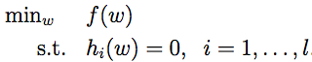

可能有的同学还能想起来这个问题可以使用拉格朗日乘数法（method of Lagrange multipliers）来解决。（没见过也不要紧哈。）在这个方法中，我们定义了一个拉格朗日函数（Lagrangian）为：

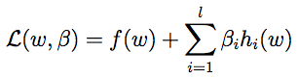

Here, the βi’s is called the Lagrange multipliers. We would then find

and set L’s partial derivatives to zero:

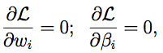

and solve for w and β. In this section, we will generalize this to constrained optimization problems in which we may have inequality as well as equality constraints. Due to time constraints, we won’t really be able to do the theory of Lagrange duality justice in this class,2 but we will give the main ideas and results, which we will then apply to our optimal margin classifier’s optimization problem.

2Readers interested in learning more about this topic are encouraged to read, e.g., R. T. Rockarfeller (1970), Convex Analysis, Princeton University Press.

Consider the following, which we’ll call the primal optimization problem:

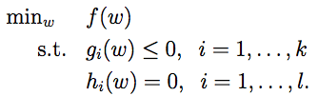

To solve it, we start by defining the **generalized Lagrangian**

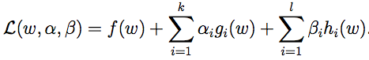

Here, the αi’s and βi’s are the Lagrange multipliers. Consider the quantity

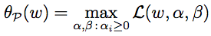

Here, the “P” subscript stands for “primal.” Let some w be given. If w violates any of the primal constraints (i.e., if either gi(w) > 0 or hi(w) ̸= 0 for some i), then you should be able to verify that

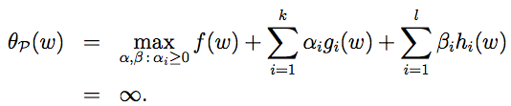

Conversely, if the constraints are indeed satisfied for a particular value of w, then θP(w) = f(w). Hence,

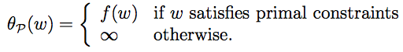

Thus, θP takes the same value as the objective in our problem for all values of w that satisfies the primal constraints, and is positive infinity if the constraints are violated. Hence, if we consider the minimization problem

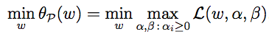

we see that it is the same problem (i.e., and has the same solutions as) our original, primal problem. For later use, we also define the optimal value of the objective to be p∗ = minw θP (w); we call this the value of the primal problem.

Now, let’s look at a slightly different problem. We define

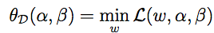

Here, the “D” subscript stands for “dual.” Note also that whereas in the definition of θP we were optimizing (maximizing) with respect to α,β, here are are minimizing with respect to w.

We can now pose the dual optimization problem:

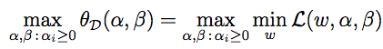

This is exactly the same as our primal problem shown above, except that the order of the “max” and the “min” are now exchanged. We also define the optimal value of the dual problem’s objective to be d∗ = maxα,β : αi≥0 θD(w).

How are the primal and the dual problems related? It can easily be shown that



(You should convince yourself of this; this follows from the “max min” of a function always being less than or equal to the “min max.”) However, under certain conditions, we will have



so that we can solve the dual problem in lieu of the primal problem. Let’s see what these conditions are.

Suppose f and the gi’s is convex,3 and the hi’s are affine.4 Suppose further that the constraints gi are (strictly) feasible; this means that there exists some w so that gi(w) < 0 for all i.

3When f has a Hessian, then it is convex if and only if the Hessian is positive semi- definite. For instance, f (w) = wT w is convex; similarly, all linear (and affine) functions are also convex. (A function f can also be convex without being differentiable, but we won’t need those more general definitions of convexity here.)

4I.e., there exists ai, bi, so that hi(w) = aTi w + bi. “Affine” means the same thing as linear, except that we also allow the extra intercept term bi.

Under our above assumptions, there must exist w∗, α∗, β∗ so that w∗ is the solution to the primal problem, α∗,β∗ are the solution to the dual problem, and moreover p∗ = d∗ = L(w∗, α∗, β∗). Moreover, w∗, α∗ and β∗ satisfy the Karush-Kuhn-Tucker (KKT) conditions, which are as follows:

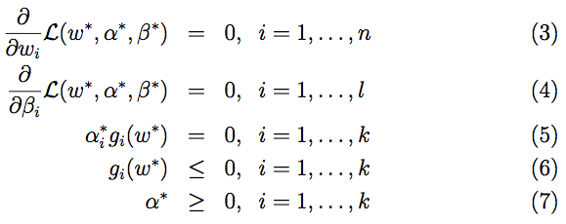

Moreover, if some w∗,α∗,β∗ satisfy the KKT conditions, then it is also a solution to the primal and dual problems.

We draw attention to Equation (5), which is called the KKT dual complementarity condition. Specifically, it implies that if αi∗ > 0, then gi(w∗) = 0. (I.e., the “gi(w) ≤ 0” constraint is active, meaning it holds with equality rather than with inequality.) Later on, this will be key for showing that the SVM has only a small number of “support vectors”; the KKT dual complementarity condition will also give us our convergence test when we talk about the SMO algorithm.

6 Optimal margin classifiers

Previously, we posed the following (primal) optimization problem for finding the optimal margin classifier:

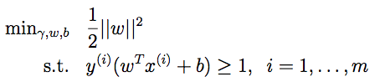

We can write the constraints as

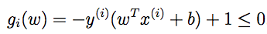

We have one such constraint for each training example. Note that from the KKT dual complementarity condition, we will have αi > 0 only for the training examples that have functional margin exactly equal to one (i.e., the ones corresponding to constraints that hold with equality, gi(w) = 0). Consider the figure below, in which a maximum margin separating hyperplane is shown by the solid line.

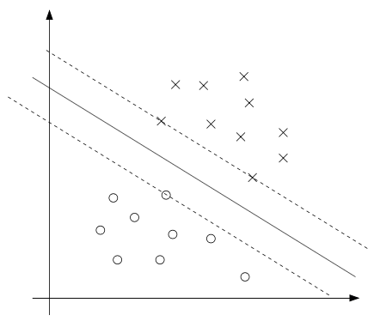

The points with the smallest margins are exactly the ones closest to the decision boundary; here, these are the three points (one negative and two pos- itive examples) that lie on the dashed lines parallel to the decision boundary. Thus, only three of the αi’s—namely, the ones corresponding to these three training examples—will be non-zero at the optimal solution to our optimiza- tion problem. These three points are called the support vectors in this problem. The fact that the number of support vectors can be much smaller than the size the training set will be useful later.

Let’s move on. Looking ahead, as we develop the dual form of the prob- lem, one key idea to watch out for is that we’ll try to write our algorithm in terms of only the inner product ⟨x(i),x(j)⟩ (think of this as (x(i))Tx(j)) between points in the input feature space. The fact that we can express our algorithm in terms of these inner products will be key when we apply the kernel trick.

When we construct the Lagrangian for our optimization problem we have:

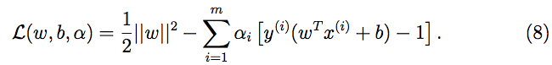

Note that there’re only “αi” but no “βi” Lagrange multipliers, since the problem has only inequality constraints.

Let’s find the dual form of the problem. To do so, we need to first minimize L(w,b,α) with respect to w and b (for fixed α), to get θD, which we’ll do by setting the derivatives of L with respect to w and b to zero. We

have:

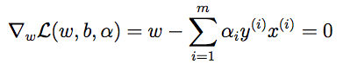

This implies that

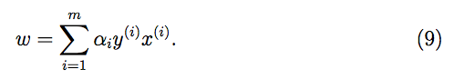

As for the derivative with respect to b, we obtain

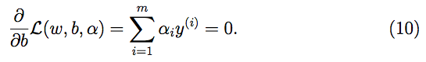

If we take the definition of w in Equation (9) and plug that back into the Lagrangian (Equation 8), and simplify, we get

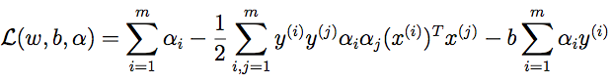

But from Equation (10), the last term must be zero, so we obtain

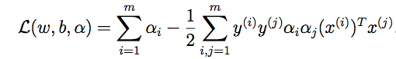

Recall that we got to the equation above by minimizing L with respect to w and b. Putting this together with the constraints αi ≥ 0 (that we always had) and the constraint (10), we obtain the following dual optimization problem:

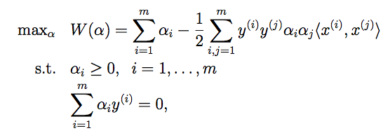

You should also be able to verify that the conditions required for p∗ = d∗ and the KKT conditions (Equations 3–7) to hold are indeed satisfied in our optimization problem. Hence, we can solve the dual in lieu of solving the primal problem. Specifically, in the dual problem above, we have a maximization problem in which the parameters are the αi’s. We’ll talk later about the specific algorithm that we’re going to use to solve the dual problem, but if we are indeed able to solve it (i.e., find the α’s that maximize W(α) subject to the constraints), then we can use Equation (9) to go back and find the optimal w’s as a function of the α’s. Having found w∗, by considering the primal problem, it is also straightforward to find the optimal value for the intercept term b as

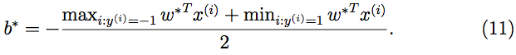

(Check for yourself that this is correct.) Before moving on, let’s also take a more careful look at Equation (9),

which gives the optimal value of w in terms of (the optimal value of) α. Suppose we’ve fit our model’s parameters to a training set, and now wish to make a prediction at a new point input x. We would then calculate wT x + b, and predict y = 1 if and only if this quantity is bigger than zero. But using (9), this quantity can also be written:

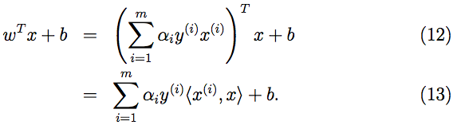

Hence, if we’ve found the αi’s, in order to make a prediction, we have to

calculate a quantity that depends only on the inner product between x and the points in the training set. Moreover, we saw earlier that the αi’s will all be zero except for the support vectors. Thus, many of the terms in the sum above will be zero, and we really need to find only the inner products between x and the support vectors (of which there is often only a small number) in order calculate (13) and make our prediction.

By examining the dual form of the optimization problem, we gained significant insight into the structure of the problem, and were also able to write the entire algorithm in terms of only inner products between input feature vectors. In the next section, we will exploit this property to apply the kernels to our classification problem. The resulting algorithm, support vector machines, will be able to efficiently learn in very high dimensional spaces.

7 Kernels

Back in our discussion of linear regression, we had a problem in which the input x was the living area of a house, and we considered performing regression using the features x, x2 and x3 (say) to obtain a cubic function. To distinguish between these two sets of variables, we’ll call the “original” input value the input attributes of a problem (in this case, x, the living area). When that is mapped to some new set of quantities that are then passed to the learning algorithm, we’ll call those new quantities the input features. (Unfortunately, different authors use different terms to describe these two things, but we’ll try to use this terminology consistently in these notes.) We will also let φ denote the feature mapping, which maps from the attributes to the features. For instance, in our example, we had

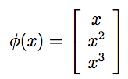

Rather than applying SVMs using the original input attributes x, we may instead want to learn using some features φ(x). To do so, we simply need to go over our previous algorithm, and replace x everywhere in it with φ(x).

Since the algorithm can be written entirely in terms of the inner products ⟨x,z⟩, this means that we would replace all those inner products with ⟨φ(x),φ(z)⟩. Specifically, given a feature mapping φ, we define the corresponding Kernel to be

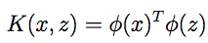

Then, everywhere we previously had ⟨x, z⟩ in our algorithm, we could simply replace it with K(x,z), and our algorithm would now be learning using the features φ.

Now, given φ, we could easily compute K(x, z) by finding φ(x) and φ(z) and taking their inner product. But what’s more interesting is that often, K(x, z) may be very inexpensive to calculate, even though φ(x) itself may be very expensive to calculate (perhaps because it is an extremely high dimensional vector). In such settings, by using in our algorithm an efficient way to calculate K(x, z), we can get SVMs to learn in the high dimensional feature space given by φ, but without ever having to explicitly find or represent vectors φ(x).

Let’s see an example. Suppose x, z ∈ Rn, and consider

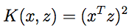

We can also write this as

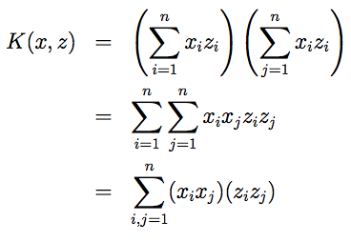

Thus, we see that K(x, z) = φ(x)T φ(z), where the feature mapping φ is given

(shown here for the case of n = 3) by

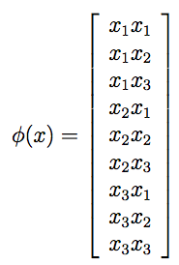

Note that whereas calculating the high-dimensional φ(x) requires O(n2) time, finding K(x,z) takes only O(n) time—linear in the dimension of the input attributes.

For a related kernel, also consider

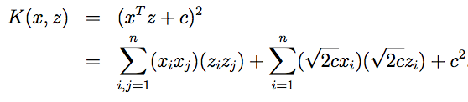

(Check this yourself.) This corresponds to the feature mapping (again shown for n = 3)

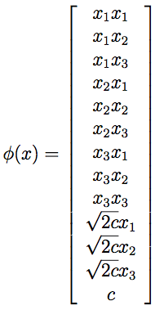

and the parameter c controls the relative weighting between the xi (first order) and the xixj (second order) terms.

More broadly, the kernel K(x, z) = (xT z + c)d corresponds to a feature mapping to an n+d feature space, corresponding of all monomials of the

d form xi1xi2 ...xik that are up to order d. However, despite working in this O(nd)-dimensional space, computing K(x,z) still takes only O(n) time, and hence we never need to explicitly represent feature vectors in this very high dimensional feature space.

Now, let’s talk about a slightly different view of kernels. Intuitively, (and there are things wrong with this intuition, but never mind), if φ(x) and φ(z) are close together, then we might expect K(x,z) = φ(x)Tφ(z) to be large. Conversely, if φ(x) and φ(z) are far apart—say nearly orthogonal to each other—then K(x, z) = φ(x)T φ(z) will be small. So, we can think of K(x, z) as some measurement of how similar are φ(x) and φ(z), or of how similar are x and z.

Given this intuition, suppose that for some learning problem that you’re working on, you’ve come up with some function K(x, z) that you think might be a reasonable measure of how similar x and z are. For instance, perhaps you chose

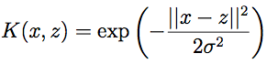

This is a resonable measure of x and z’s similarity, and is close to 1 when x and z are close, and near 0 when x and z are far apart. Can we use this definition of K as the kernel in an SVM? In this particular example, the answer is yes. (This kernel is called the Gaussian kernel, and corresponds to an infinite dimensional feature mapping φ.) But more broadly, given some function K, how can we tell if it’s a valid kernel; i.e., can we tell if there is some feature mapping φ so that K(x, z) = φ(x)T φ(z) for all x, z?

Suppose for now that K is indeed a valid kernel corresponding to some feature mapping φ. Now, consider some finite set of m points (not necessarily the training set) {x(1),...,x(m)}, and let a square, m-by-m matrix K be defined so that its (i, j )-entry is given by Kij = K (x(i) , x(j ) ). This matrix is called the Kernel matrix. Note that we’ve overloaded the notation and used K to denote both the kernel function K(x,z) and the kernel matrix K, due to their obvious close relationship.

Now, if K is a valid Kernel, then Kij = K(x(i), x(j)) = φ(x(i))T φ(x(j)) = φ(x(j))T φ(x(i)) = K(x(j), x(i)) = Kji, and hence K must be symmetric. More- over, letting φk(x) denote the k-th coordinate of the vector φ(x), we find that for any vector z, we have

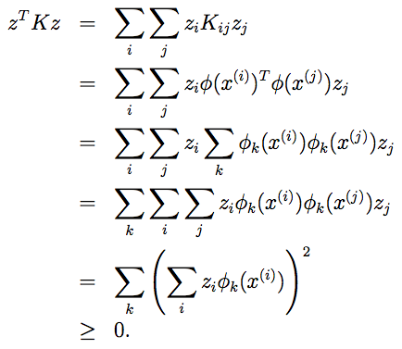

The second-to-last step above used the same trick as you saw in Problem set 1 Q1. Since z was arbitrary, this shows that K is positive semi-definite (K ≥ 0).

Hence, we’ve shown that if K is a valid kernel (i.e., if it corresponds to some feature mapping φ), then the corresponding Kernel matrix K ∈ Rm×m is symmetric positive semidefinite. More generally, this turns out to be not only a necessary, but also a sufficient, condition for K to be a valid kernel (also called a Mercer kernel). The following result is due to Mercer.5

5Many texts present Mercer’s theorem in a slightly more complicated form involving L2 functions, but when the input attributes take values in Rn, the version given here is equivalent.

Theorem (Mercer). Let K : Rn × Rn → R be given. Then for K to be a valid (Mercer) kernel, it is necessary and sufficient that for any {x(1),...,x(m)}, (m < ∞), the corresponding kernel matrix is symmetric positive semi-definite.

Given a function K, apart from trying to find a feature mapping φ that corresponds to it, this theorem therefore gives another way of testing if it is a valid kernel. You’ll also have a chance to play with these ideas more in problem set 2.

In class, we also briefly talked about a couple of other examples of ker- nels. For instance, consider the digit recognition problem, in which given an image (16x16 pixels) of a handwritten digit (0-9), we have to figure out which digit it was. Using either a simple polynomial kernel K(x, z) = (xT z)d or the Gaussian kernel, SVMs were able to obtain extremely good perfor- mance on this problem. This was particularly surprising since the input attributes x were just a 256-dimensional vector of the image pixel intensity values, and the system had no prior knowledge about vision, or even about which pixels are adjacent to which other ones. Another example that we briefly talked about in lecture was that if the objects x that we are trying to classify are strings (say, x is a list of amino acids, which strung together form a protein), then it seems hard to construct a reasonable, “small” set of features for most learning algorithms, especially if different strings have dif- ferent lengths. However, consider letting φ(x) be a feature vector that counts the number of occurrences of each length-k substring in x. If we’re consid- ering strings of english letters, then there are 26k such strings. Hence, φ(x) is a 26k dimensional vector; even for moderate values of k, this is probably too big for us to efficiently work with. (e.g., 264 ≈ 460000.) However, using (dynamic programming-ish) string matching algorithms, it is possible to ef- ficiently compute K(x,z) = φ(x)Tφ(z), so that we can now implicitly work in this 26k-dimensional feature space, but without ever explicitly computing feature vectors in this space.

The application of kernels to support vector machines should already be clear and so we won’t dwell too much longer on it here. Keep in mind however that the idea of kernels has significantly broader applicability than SVMs. Specifically, if you have any learning algorithm that you can write in terms of only inner products ⟨x,z⟩ between input attribute vectors, then by replacing this with K(x,z) where K is a kernel, you can “magically” allow your algorithm to work efficiently in the high dimensional feature space corresponding to K. For instance, this kernel trick can be applied with the perceptron to derive a kernel perceptron algorithm. Many of the algorithms that we’ll see later in this class will also be amenable to this method, which has come to be known as the “kernel trick.”

8 Regularization and the non-separable case

The derivation of the SVM as presented so far assumed that the data is linearly separable. While mapping data to a high dimensional feature space via φ does generally increase the likelihood that the data is separable, we can’t guarantee that it always will be so. Also, in some cases it is not clear that finding a separating hyperplane is exactly what we’d want to do, since that might be susceptible to outliers. For instance, the left figure below shows an optimal margin classifier, and when a single outlier is added in the upper-left region (right figure), it causes the decision boundary to make a dramatic swing, and the resulting classifier has a much smaller margin.

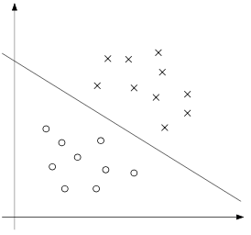 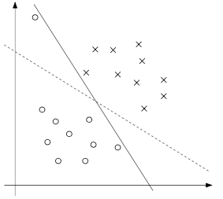

To make the algorithm work for non-linearly separable datasets as well as be less sensitive to outliers, we reformulate our optimization (using l1 regularization) as follows:

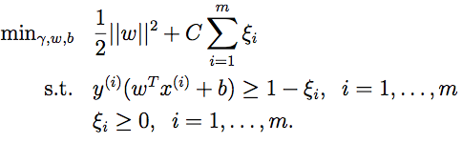

Thus, examples are now permitted to have (functional) margin less than 1, and if an example has functional margin 1 − ξi (with ξ > 0), we would pay a cost of the objective function being increased by Cξi. The parameter C controls the relative weighting between the twin goals of making the ||w||2 small (which we saw earlier makes the margin large) and of ensuring that most examples have functional margin at least 1.

As before, we can form the Lagrangian:



Here, the αi’s and ri’s are our Lagrange multipliers (constrained to be ≥ 0). We won’t go through the derivation of the dual again in detail, but after setting the derivatives with respect to w and b to zero as before, substituting them back in, and simplifying, we obtain the following dual form of the problem:

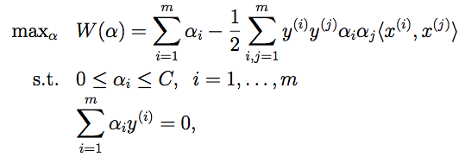

As before, we also have that w can be expressed in terms of the αi’s as given in Equation (9), so that after solving the dual problem, we can continue to use Equation (13) to make our predictions. Note that, somewhat surprisingly, in adding l1 regularization, the only change to the dual problem is that what was originally a constraint that 0 ≤ αi has now become 0 ≤ αi ≤ C. The calculation for b∗ also has to be modified (Equation 11 is no longer valid); see the comments in the next section/Platt’s paper.

Also, the KKT dual-complementarity conditions (which in the next section will be useful for testing for the convergence of the SMO algorithm) are:

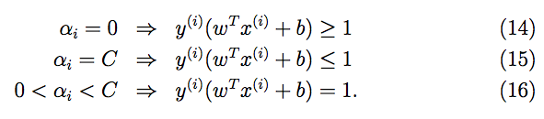

Now, all that remains is to give an algorithm for actually solving the dual problem, which we will do in the next section.

9 The SMO algorithm

The SMO (sequential minimal optimization) algorithm, due to John Platt, gives an efficient way of solving the dual problem arising from the derivation of the SVM. Partly to motivate the SMO algorithm, and partly because it’s interesting in its own right, let’s first take another digression to talk about the coordinate ascent algorithm.

9.1 Coordinate ascent

Consider trying to solve the unconstrained optimization problem

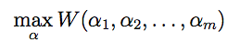

Here, we think of W as just some function of the parameters αi’s, and for now ignore any relationship between this problem and SVMs. We’ve already seen two optimization algorithms, gradient ascent and Newton’s method. The new algorithm we’re going to consider here is called coordinate ascent:

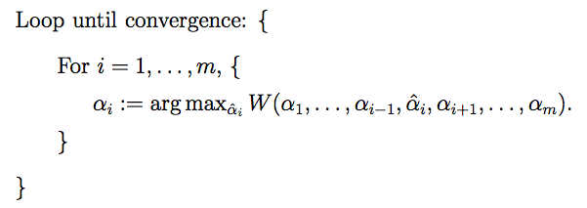

Thus, in the innermost loop of this algorithm, we will hold all the vari- ables except for some αi fixed, and reoptimize W with respect to just the parameter αi. In the version of this method presented here, the inner-loop reoptimizes the variables in order α1, α2, . . . , αm, α1, α2, . . .. (A more sophis- ticated version might choose other orderings; for instance, we may choose the next variable to update according to which one we expect to allow us to make the largest increase in W(α).)

When the function W happens to be of such a form that the “arg max” in the inner loop can be performed efficiently, then coordinate ascent can be a fairly efficient algorithm. Here’s a picture of coordinate ascent in action:

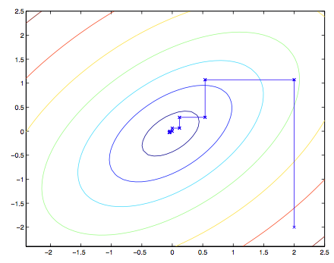

The ellipses in the figure are the contours of a quadratic function that we want to optimize. Coordinate ascent was initialized at (2,−2), and also plotted in the figure is the path that it took on its way to the global maximum. Notice that on each step, coordinate ascent takes a step that’s parallel to one of the axes, since only one variable is being optimized at a time.

9.2 SMO

We close off the discussion of SVMs by sketching the derivation of the SMO algorithm. Some details will be left to the homework, and for others you may refer to the paper excerpt handed out in class.

Here’s the (dual) optimization problem that we want to solve:

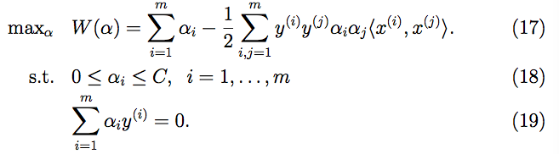

Let’s say we have set of αi’s that satisfy the constraints (18-19). Now, suppose we want to hold α2, . . . , αm fixed, and take a coordinate ascent step and reoptimize the objective with respect to α1. Can we make any progress? The answer is no, because the constraint (19) ensures that

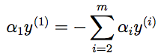

Or, by multiplying both sides by y(1), we equivalently have

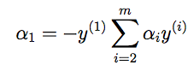

(This step used the fact that y(1) ∈ {−1, 1}, and hence (y(1))2 = 1.) Hence, α1 is exactly determined by the other αi’s, and if we were to hold α2, . . . , αm fixed, then we can’t make any change to α1 without violating the con- straint (19) in the optimization problem.

Thus, if we want to update some subject of the αi’s, we must update at least two of them simultaneously in order to keep satisfying the constraints. This motivates the SMO algorithm, which simply does the following:

Repeat till convergence {

1. Select some pair αi and αj to update next (using a heuristic that tries to pick the two that will allow us to make the biggest progress towards the global maximum).
2. Reoptimize W(α) with respect to αi and αj, while holding all the other αk’s (k ̸= i, j) fixed.

}

To test for convergence of this algorithm, we can check whether the KKT conditions (Equations 14-16) are satisfied to within some tol. Here, tol is the convergence tolerance parameter, and is typically set to around 0.01 to 0.001. (See the paper and pseudocode for details.)

The key reason that SMO is an efficient algorithm is that the update to αi, αj can be computed very efficiently. Let’s now briefly sketch the main ideas for deriving the efficient update.

Let’s say we currently have some setting of the αi’s that satisfy the con- straints (18-19), and suppose we’ve decided to hold α3, . . . , αm fixed, and want to reoptimize W (α1, α2, . . . , αm) with respect to α1 and α2 (subject to the constraints). From (19), we require that

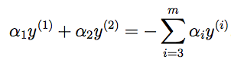

Since the right-hand side is fixed (as we’ve fixed α3, . . . αm), we can just let it be denoted by some constant ζ:



We can thus picture the constraints on α1 and α2 as follows:

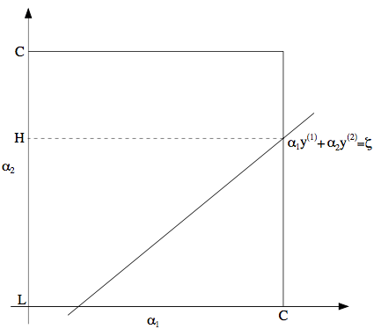

From the constraints (18), we know that α1 and α2 must lie within the box [0,C]×[0,C] shown. Also plotted is the line α1y(1) +α2y(2) = ζ, on which we know α1 and α2 must lie. Note also that, from these constraints, we know L ≤ α2 ≤ H; otherwise, (α1,α2) can’t simultaneously satisfy both the box and the straight-line constraint. In this example, L = 0. But depending on what the line α1y(1) + α2y(2) = ζ looks like, this won’t always necessarily be the case; but more generally, there will be some lower-bound L and some upper-bound H on the permissible values for α2 that will ensure that α1, α2 lie within the box [0, C] × [0, C].

Using Equation (20), we can also write α1 as a function of α2:

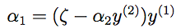

(Check this derivation yourself; we again used the fact that y(1) ∈ {−1, 1} so that (y(1))2 = 1.) Hence, the objective W(α) can be written



Treating α3,...,αm as constants, you should be able to verify that this is just some quadratic function in α2. I.e., this can also be expressed in the form aα2 + bα2 + c for some appropriate a, b, and c. If we ignore the “box” constraints (18) (or, equivalently, that L ≤ α2 ≤ H), then we can easily maximize this quadratic function by setting its derivative to zero and solving. We’ll let αnew,unclipped denote the resulting value of α . You should also be 22 able to convince yourself that if we had instead wanted to maximize W with respect to α2 but subject to the box constraint, then we can find the resulting value optimal simply by taking αnew,unclipped and “clipping” it to lie in the [L,H] interval, to get

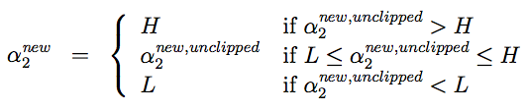

Finally, having found the αnew, we can use Equation (20) to go back and find the optimal value of αnew. 1

There’re a couple more details that are quite easy but that we’ll leave you to read about yourself in Platt’s paper: One is the choice of the heuristics used to select the next αi, αj to update; the other is how to update b as the SMO algorithm is run.